Technical Documentation

Classes and Functions:

1. Class – Form1
   1. Function – isLeap()
      * + Returns if the input year is leap or not
        + Algorithm – checks if the year is divisible by 400, 100, or 4 and returns value accordingly
   2. Subroutine – fillBoxes()
      * + Takes in row of textboxes and also the first day and fills them accordingly.
   3. Function – dayOfWeek()
      * + Takes in the date as argument and returns the day of week .
        + Algorithm – Source – <https://en.wikipedia.org/wiki/Determination_of_the_day_of_the_week>
   4. Function - Button1_Click()
      * + Fills table after checking if the given input is a leap year or a non-leap
   5. Subroutine – initializeColor()
      * + Initializes the colour of all text boxes
   6. Function – Highlight()
      * + Takes in input a weekday and a row of textboxes and highlights the colour of textboxes accordingly.
   7. Subroutine – Button2_Click()
      * + Initializes all the textboxes first and reads from combo box and highlights the weekday according to the input.
   8. Function – PrintCal()
      * + Returns the calender of a month of a particular year in form of a string.
        + Algorithm – It calculates the weekday of the first day of the month and appends the rest of the days with appropriate spacing.
   9. Subroutine – Button3_Click()
      * + Does error checking on the input given in combo box and prints the calender in a new form – form2 using the printCal() function.

Flowchart (Button1):

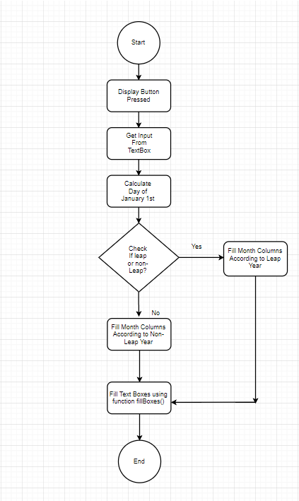

Flowchart (Button2):

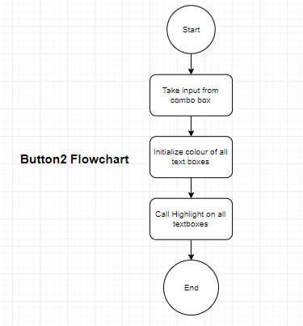

Flowchart (Button3):

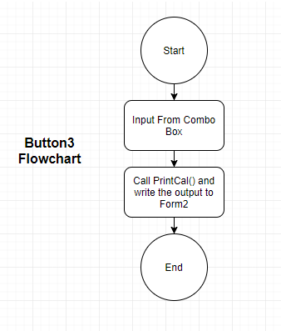

Corner Cases:

1. Decimal input not allowed
2. Negative input not allowed
3. String input not allowed
4. Very large number not allowed

Future Modifications:

1. Print Calender for a specific month
2. Add Customizable UI options
3. Highlight a particular day

Shortcomings:

1. Very large number(~ above 1010) cannot be handled

This project was made on Microsoft Visual Studio 2013